RAJEEV RANJAN 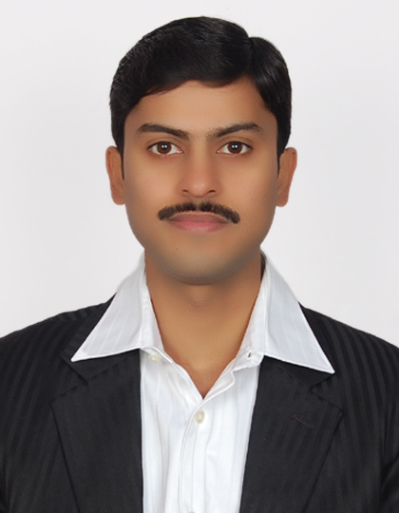

Ph: 9540095333
Email: rajeevranjan19982@gmail.com

Career Objective: - A Challenging position in a professional organization where i could enhance my skill & strength in conjunction with the company’s goal & objectives.

Strengths and Qualities
- A seasoned professional with nearly 8 years of intensive & rich experience in Life/General Insurance operations.
- Hard Working & Honest.
- Positive Attitude, Good Grasping Power.
- Self Motivating.
- Able to compete with the deadlines
- Sincere with work and energetic at professional front

Proficiency Forte

Customer Service:

- To log the calls in Talisma software for the approved requests.
- To process the requests of customers regarding policy service like Fund Switch, Premium Payment mode change, contact details, free-look request, refund cheques etc.
- To track record of Policy Document and take care of timely dispatch of PD to customer.

Underwriting and Issuance:
- Under writing of all Non- Medical cases at branch level.
- Coordination with Central Operation for issuance.
- To create Client & Contract and Policy generation.
- Coordination with Central Operation for subsequent and medical issuance.
- Looking discrepancy raised by HO in fresh Proposal forms
- Looking receipting of cash and cheque for initial and renewal cases.
- Follow ups with HO for delay in issuance of new business.
- Escalation & Resolution of Sales/Ops complaint cases for cancellation & refund of Initial premium to Customers.
- Processing withdrawal at Proposal / Policy stage refunds of initial premium to Resolving customer complaints & queries related to policy dispatch.
- Responsible for processing and verification of document provided by the various sales channel.
- Handling issues related to policy revival and claims.

Finance:

- Receipting & Banking of new business and renewals premium.
- Timely delivery of Cash & Cheques to bankers & maintaining the physical files of same.
- Looking finance (Petty cash, Third Party vendor’s payments, Bank Reconciliation).
- To manage petty cash expenses in branch.
- To maintain the physical files of expense bills & sending the same to HO on monthly basis.
- To keep track of the vendor bills as per agreements.

Branch Admin:
- To maintain the house keeping material & pantry goods.
- To mark attendance of office boys & keep track of their payments of salary.
- To administer the cleaning of office & maintenance of office assets.
- To maintain the stationary & other office routine requirements.

Assist the claims team at HO in all related issues.

- Ensure that all required documents are submitted along with the Claim docs
- Coordinate with the Advisors, AMs and the Claims team in HO.

WORK EXPERIENCES

May 2010 to – Continued
Branch Operation Executive- Senior Executive with Birla Sun Life Insurance Co Ltd. (Gurgaon2 Branch at Sohna Road, Gurgaon, Haryana)

Payroll: Company Payroll
Reporting: Team Manager-Ops/Finance
Assignments Handled: Back Office Operations, Customer Services, Receipting and Banking, Primary Underwriting.

Jul 2007 to – Apr 2010
Operation Officer- Branch Operations with Bajaj Allianz General Insurance company Ltd. (Moti Nagar Branch, New Delhi)

Payroll: Bajaj Allianz Staffing Solution
Reporting: Operation Manager
Assignments Handled: Leading and Coordinating the Process of Policy Issuance after Quality Check, Acceptance & Banking of Cheque, Monitoring & Handling of Policy generation, Policy Dispatch, Endorsement in Policy & Cancellation of Policies, Customer Services.

Sep 06 – Jun 2007
Operation Associate- Branch Operations with ICICI Lombard General Insurance Company Ltd (CP Branch, New Delhi)

Payroll: Team Lease
Reporting: Operation Manager
Assignments Handled: Quality Check of application, Policy Issuance and Endorsement in policy.

ACHIEVEMENTS IN CAREER

- Foundation program for Operational excellence training completed level-1 with 94% marks, in Jaipur presented by Head-Zonal operation, Birla Sun Life Insurance Co ltd. Dec 2010.
- Excellence award recognition of outstanding performance in operations during financial year end closing 2009-10 presented by CEO, Bajaj Allianz General Insurance Co. ltd. Apr 2010.
- Excellence award for Assessments of the I-Quest program which cover all General insurance products, in Delhi presented by HR Head, Bajaj Allianz General Insurance Co. ltd. May 2008.

ACADEMIC CREDENTIALS

Standard | Board/University | Year Passed | Division/Marks
PGDBM | Bharati Vidyapeeth, Pune University, New Delhi | 2007 | 50%
B.Com (H) | Patna University, Patna, Bihar | 2002 | 72%
I.A. | Bihar National Collage, Patna, Bihar | 1999 | 58%
10th | Gyan Niketan, Patna, Bihar | 1997 | 59%

PERSONAL VITAE

Date of Birth : 19th Sep 1982
Father’s Name : Sh. Raghubir Prasad
Marital Status : Married
Languages Known : Hindi & English
Hobbies : Listening to Songs.
Address : Plot No 4, 3rd floor, Sainik Enclave, Vipin Garden, Dwarka More, New Delhi-110059

Declaration:
I hereby declare that the facts mentioned herewith are true to my best knowledge and belief.

(Rajeev Ranjan)

